**Objective:**

**IMPORTANT !**   
1. Install WSL2, ubuntu 22.04 

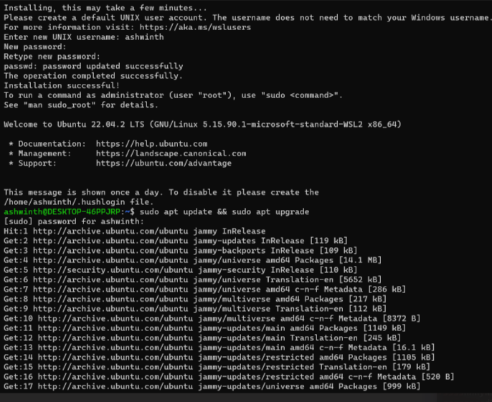

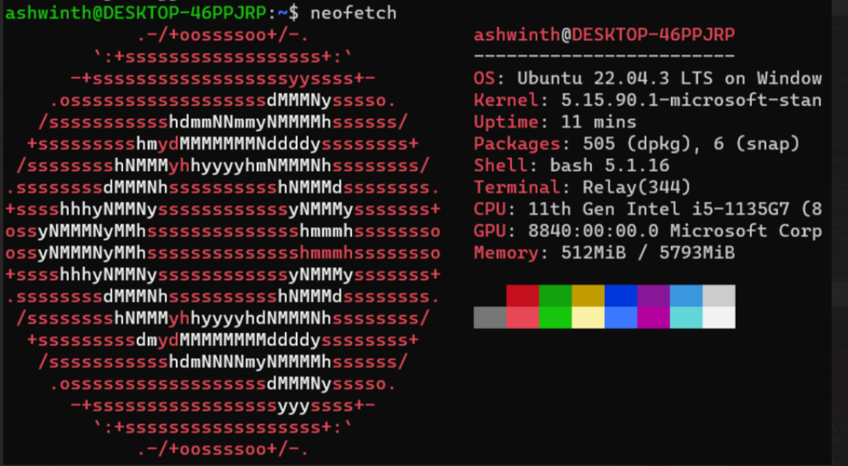

2. Git Basics - Create a new repo called internship  
    Create new branch Prod, Dev, QA.  
                Git clone , pull, add, commit, push, stash

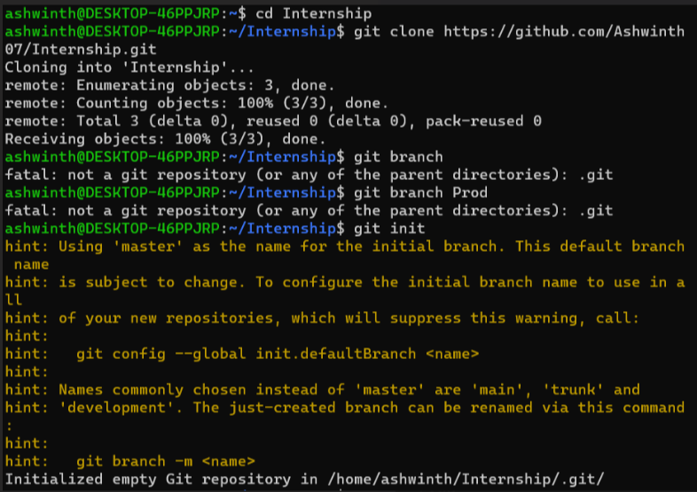

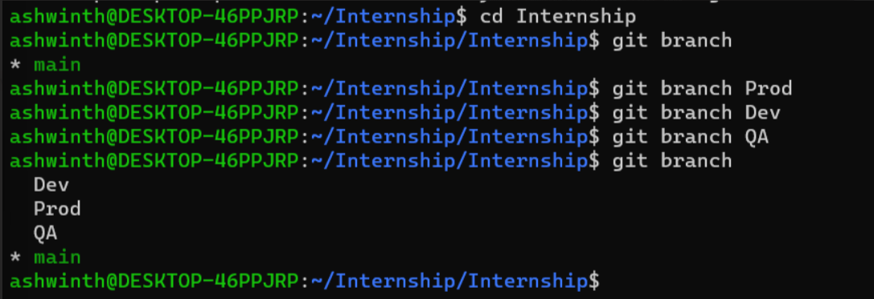

3. Set virtual environment in it.

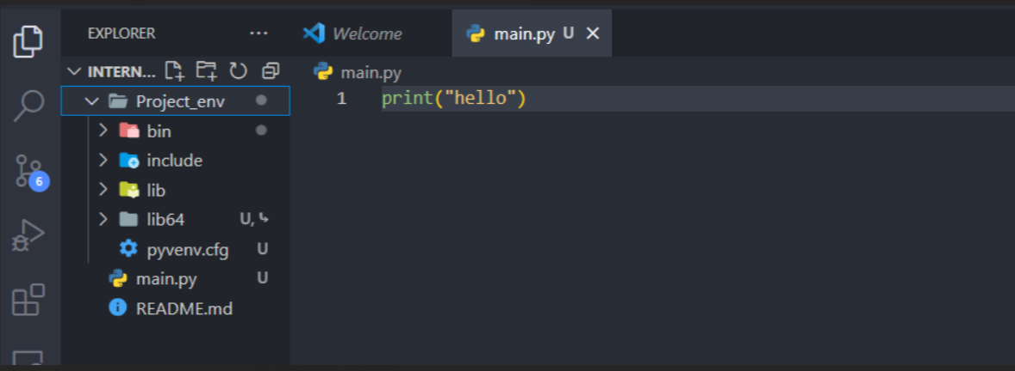

4. Create a directory called internship in home directory

